Mobile App for Detecting Artificially Ripened Bananas Using Computer Vision and Colorimetric Analysis
A Project Report submitted in partial fulfillment of the requirements
for the award of the degree of


BACHELOR OF TECHNOLOGY
in
COMPUTER SCIENCE AND ENGINEERING
(Specialization in Data Science)

Submitted by
B. Sri Keerthi Chandra (HU22CSEN0500203)
Lercha Vikas (HU22CSEN0500090)
Guneet Singh (HU22CSEN0500076)
E. Harsha Vardan Reddy (HU22CSEN0500034)

Under the esteemed guidance of
Dr. S Rama Krishna
Associate Professor



Department of Artificial Intelligence and Data Science
GITAM School of CSE, GITAM (Deemed to be University)
Hyderabad
2026

Department of Artificial Intelligence and Data Science
YEAR
GITAM School of CSE, GITAM (Deemed to be University)
Hyderabad

DECLARATION

I hereby declare that the project report entitled Mobile App for Detecting Artificially Ripened Bananas Using Computer Vision and Colorimetric Analysis is an original work done in the Department of Data Science, GITAM School of CSE, GITAM (Deemed to be University) submitted in partial fulfillment of the requirements for the award of B. Tech Degree in Computer Science and Engineering (Specialization in Data Science).

The work has not been submitted to any other college or University for the award of any degree or diploma.

Date:

Registration No’s | Name’s | Signature
HU22CSEN0500203 | B. Sri Keerthi Chandra
HU22CSEN0500090 | Lercha Vikas
HU22CSEN0500076 | Guneet Singh
HU22CSEN0500034 | E. Harsha Vardan Reddy

Department of Artificial Intelligence and Data Science
GITAM School of CSE, GITAM (Deemed to be University)
Hyderabad

CERTIFICATE

This is to certify that the project report entitled “Mobile App for Detecting Artificially Ripened Bananas Using Computer Vision and Colorimetric Analysis” is a bonafide record of work carried out by B. Sri Keerthi Chandra (HU22CSEN0500203), Lercha Vikas (HU22CSEN0500090), Guneet Singh (HU22CSEN0500076), E. Harsha Vardan Reddy (HU22CSEN0500034), students of this department submitted in partial fulfillment of requirements for the award of B.Tech Degree in Computer Science and Engineering (Specialization in Data Science

Date:

Dr. S Rama Krishna | Dr. A B Pradeep Kumar | Dr. V Sireesha
Project Guide | Project Coordinator | Head Of the Department

ACKNOWLEDGEMENT
Our project report entitled “Mobile App for Detecting Artificially Ripened Bananas Using Computer Vision and Colorimetric Analysis” .
We express our sincere gratitude to our honorable Pro-Vice-Chancellor, Prof. D. Sambasiva Rao, for providing the necessary infrastructure and resources for carrying out this project successfully.
We are very much obliged to our respected Head of the Department, Dr. Shaik Mahaboob Basha, for providing us with the opportunity to undertake this project and for his encouragement throughout its completion.
We would like to express our deep sense of gratitude to Dr. A. B. Pradeep Kumar, Project Coordinator, Department of Computer Science and Engineering, for his valuable guidance and support.
We extend our heartfelt thanks to our project guide, Dr. S. Rama Krishna, for his constant guidance, motivation, and valuable suggestions that helped us in the successful completion of this project.
We are also thankful to all the faculty members of the Department of Computer Science and Engineering for their support. Finally, we would like to thank our parents and friends for their encouragement and moral support throughout the project work.

Sincerely,
B. Sri Keerthi Chandra – HU22CSEN0500203
Lercha Vikas – HU22CSEN0500090
Guneet Singh – HU22CSEN0500076
E. Harsha Vardaan Reddy – HU22CSEN0500034

ABSTRACT

Artificial ripening of bananas by means of chemical agents is a major food safety issue, since it cannot be successfully detected through visual observation. This project suggests a machine-based image-based classification method to differentiate between naturally and artificially ripened bananas with a hybrid solution incorporating deep learning and machine learning methods.

The proposed technique takes advantage of transfer learning to extract features in RGB images and color-based feature representation to identify fine differences in the properties of fruits. The classification model processes these features to effectively determine the category of ripening. Several model configurations are compared to decide which one is the most effective.

The findings indicate that the suggested system is highly successful in classification, and it also offers high reliability in detecting artificially ripened fruits. Further, explainable AI methods are added to make the decisions of models more interpretable. The established system may be incorporated into the practical world, allowing an efficient and convenient evaluation of the quality of fruits using online platforms.

Table of Contents
CHAPTER 1: INTRODUCTION 1
1.1 Introduction 1
1.2 Objectives 1
1.3 Problem Statement 2
1.4 Scope of the Project 2
1.5 Applications 2
1.6 Overview 2
CHAPTER 2: LITERATURE REVIEW 3
2.1 Problem Definition 3
2.2 Review of Existing Systems and Literature 3
2.2.1 Detection and Identification of Artificially Ripened Fruits using Image Processing 3
2.2.2 A Consumer-Friendly Machine Learning Based Method to Detect Artificial Fruit Ripening 3
2.2.3 Classification of Fruits Ripeness using CNN with Multivariate Analysis by SGD 3
2.2.4 Detection of Fruit Ripeness and Defectiveness Using Texture and Colour Features (IDA Journal, 2024) 3
2.3 Limitations of Existing Literature Systems 4
2.3.1 Detection and Identification of Artificially Ripened Fruits using Image Processing 4
2.3.2 A Consumer-Friendly Machine Learning Based Method to Detect Artificial Fruit Ripening (IJEAT, 2020) 4
2.3.3 Classification of Fruits Ripeness using CNN with Multivariate Analysis by SGD (Kamble et al., 2022) 4
2.3.4 Detection of Fruit Ripeness and Defectiveness Using Texture and Color Features (IDA Journal, 2024) 4
2.4 Research Gap 4
2.5 Summary 4
CHAPTER 3: PROPOSED METHODOLOGY 5
3.1 System Overview and Architecture 5
3.2 Description and Collection of Dataset 5
3.2.1 Description of Dataset 5
3.2.2 Pre-existing Dataset 5
3.2.3 Manual Dataset Collection 5
3.2.4 Dataset Combination and Splitting 6
3.2.5 Final Dataset Distribution 6
3.3 Data Preprocessing 6
3.4 Color Feature Engineering (HSV and LAB) 6
3.5 CNN Feature Extraction Using Transfer Learning 7
3.6 Classification Models 8
3.7 Hyperparameter Optimization Strategy 10
3.8 Technologies and Tools Used 10
3.9 Functional Requirements 11
CHAPTER 4: MOBILE IMPLEMENTATION 12
4.1 Introduction and Overview of Mobile Technology 12
4.2 System Architecture and Integration 12
4.3 Application Design and Navigation 12
4.4 API Configuration and Communication 12
4.5 Image Processing, Model Interaction, and Deployment 13
4.6 Mobile Application Screens and Workflow 13
CHAPTER 5: RESULT ANALYSIS 14
5.1 Overview of Evaluation 14
5.2 Evaluation Metrics 14
5.3 Model Comparison — All 12 Combinations (4 CNN × 3 Classifiers) 15
5.3.1. CNN Backbones and Architecture Details 15
5.3.2. Classifiers 15
5.3.3 Observations 16
5.3.4 Accuracy vs. Parameters Visualization: 16
5.4 Why EfficientNetB0 + ANN is the Best Combination 17
5.5 Hyperparameter Optimisation Results 17
5.5.1 Accuracy vs Parameter Count 18
5.5.2 Epochs vs Accuracy 18
5.5.3 Selection of Optimal Configuration (Run 376) 19
5.6 Statistical Significance Testing 20
5.7 Ablation Study 20
5.7.1 Feature Extractor Analysis 20
5.7.2 Classifier Analysis 21
5.7.3 Complexity vs Performance 21
5.7.4 Ablation Analysis — Colour Features vs CNN Features 21
5.8 Explainable AI Results 21
5.8.1 SHAP Feature Importance — Global Analysis 21
5.8.2 Grad-CAM — Visual Attention Heatmaps 22
5.9 Summary of Results 23
CHAPTER 6: CONCLUSION AND FUTURE SCOPE 24
6.1 Conclusion 24
6.2 Future Scope 24
CHAPTER 7: REFERENCES 25
Chapter 8: Project Proforma 26

CHAPTER 1: INTRODUCTION

1.1 Introduction
Due to the fast development of computer vision and machine learning technologies, automated systems are becoming more popular in agriculture and food quality evaluation. The identification of the fruit ripeness is one of the most important points in this sphere as it directly affects the food quality, safety, and the market value. Specifically, the process of applying chemical agents to artificially ripen fruits has been raising an increasing concern, as it is potentially hazardous to human health, and cannot be fully detected by the means of manual inspection.
Conventional fruit ripeness detection techniques consider the use of human perception of phenomena, including color, texture, and appearance. Nevertheless, they are subjective, inconsistent, and time-consuming techniques, so they could not be applied to large-scale and precise quality analysis. Consequently, automated and dependable methods that would objectively differentiate between naturally and artificially ripened fruits are required.
The project suggests the Banana fruit ripeness classification based on the image as an automated system, and it uses the potential offered by the method of machine learning and deep learning. The system will identify the correct classification of fruits in accordance with their ripening process by analyzing the visual features obtained by processing the images of the fruit. The proposed solution is aimed at offering a scalable, efficient, and reliable way to monitor the quality of food, which will lead to a better level of consumer safety and decision-making.

1.2 Objectives
The primary aims of this project will be:
- To create a machine-based method of categorizing bananas into naturally and artificially ripened bananas by analyzing images.
- To build and preprocess a labelled dataset of banana images that can be used to train and test.
- To obtain meaningful visual features of images with the help of transfer learning.
- To create and establish a workable classification model to detect ripeness.
- To compare and contrast several combinations of models to determine the most appropriate one to use in the task.
- To search for and optimize the chosen model using systematic hyperparameter tuning to achieve better performance.
- To integrate Explainable AI to understand feature importance and explain model predictions.
- To create an integrated system that should be able to give credible predictions in a situation of real application.

1.3 Problem Statement
Ripening bananas manually with the help of the chemicals, like calcium carbide is a common practice that is raising great food safety issues. These chemicals emit gases that resemble natural ripening hormones making fruits to look like those that have been naturally ripened in color and texture. Consequently, it is hard to tell the difference between naturally ripened and those that have been artificially ripened bananas by looking at them.
Manual-induced observation techniques are unreliable and inconsistent, and thus, there is a need to have an automated and correct process of identifying the ripening process. This type of system can be used to enhance food quality evaluation and consumer safety.

1.4 Scope of the Project
- The project is based on binary classification of banana as naturally ripened and artificially ripened depending on visual properties.
- The system employs image analysis in which input images are preprocessed and standardized to fit in the model.
- It is restricted to non-invasive procedures and does not entail chemical, spectroscopic or physical testing procedures.
- The system developed can produce predictions in addition to confidence scores, and it can be used practically in the real-life scenario.
- It is limited to controlled settings of image and can change in performance with extreme changes in lighting, background or image quality.

1.5 Applications
- Market/ warehouse and port of entry food safety inspection.
- Mobile applications to verify the quality of the bananas prior to purchase.
- Enhancement to automatic pipelines of quality control and sorting of agriculture.
- Technological resource demonstrating the role of AI in food safety and agriculture.
- Food safety regulatory compliance tool: This is designed to enable regulatory agencies to carry the quick field inspection without carrying laboratory equipment.

1.6 Overview
This report gives the creation of the automated process of banana ripeness detection through image analysis. It addresses the context of the problem, the existing methodologies review, the proposed methodology, and the implementation of the system and its performance analysis. The effectiveness of the proposed approach is also addressed in the report and some improvements that can be made on future work are discussed.

CHAPTER 2: LITERATURE REVIEW

2.1 Problem Definition
The identification of artificially ripened bananas involves a unique technical issue in the context of food quality evaluation. In contrast to staged ripeness identification, in which the change in color is natural and can be predicted accurately, the issue at hand involves the identification of minor colorimetric and texture anomalies caused due to chemical agents like calcium carbide, which differentiate an artificially ripened banana from the naturally ripened one. Since such anomalies are not easily detectable by the naked eye, it is possible to use the image analysis technique for such detection purposes.

2.2 Review of Existing Systems and Literature

2.2.1 Detection and Identification of Artificially Ripened Fruits using Image Processing
In particular, this research considered the discrimination between naturally ripened and artificially ripened bananas based on imaging analysis only. Images in RGB format were taken of banana samples, while mean, variance, contrast, color histograms, etc. were used as features to characterize the crops based on color and texture features. Next, a K-Nearest Neighbors classifier was utilized to classify the samples. This paper provides insights into our current project, since it is shown that the visual characteristics of the fruit can be useful in discriminating artificially ripened fruits, and this can be achieved by means of image analysis.

2.2.2 A Consumer-Friendly Machine Learning Based Method to Detect Artificial Fruit Ripening
The research conducted concentrated solely on classifying naturally ripened bananas against artificially ripened bananas with calcium carbide via an image processing-based pipeline. RGB images were collected and statistical color and texture features such as mean, variance, contrast and histogram of colors were derived through crop analysis. The KNN classifier was utilized to determine whether bananas were natural or artificial based on the extracted features. This research provides direct correlation with the current project since it shows that discriminative information can be obtained by observing the surface characteristics, which can then be used for classification.

2.2.3 Classification of Fruits Ripeness using CNN with Multivariate Analysis by SGD
Kamble et al. presented a deep learning algorithm for ripeness classification based on the adapted VGG architecture of CNN, which was trained on RGB images containing multiple types of fruits such as banana, mango, apple, orange, and papaya. The network was optimized using Stochastic Gradient Descent (SGD), underwent nearly 38 training epochs, and attained classification accuracy close to 96.5%, surpassing conventional algorithms like KNN, SVM, and basic neural networks in the same application scenario. This research is noteworthy since it provides evidence for employing CNNs in color-based fruit detection and highlights that deep learning models can effectively learn visual discriminators through raw pixel values rather than relying on manually extracted features.

2.2.4 Detection of Fruit Ripeness and Defectiveness Using Texture and Colour Features (IDA Journal, 2024)
The research by Kamble et al. has presented a method to classify ripe fruits through deep learning, where an improved VGG-like architecture is used as the Convolutional Neural Network (CNN) in order to train it based on the RGB pictures of different fruits, such as banana, mango, apple, orange, and papaya. The learning process was carried out by Stochastic Gradient Descent (SGD), which took about 38 epochs, achieving an accuracy of roughly 96.5%. This performance exceeded classical machine learning techniques such as KNN, SVM, and shallow neural networks. The significance of this study lies in the verification of CNNs' applicability to color-based fruit analysis and in their ability to learn discriminative visual cues from raw pixel images.

2.3 Limitations of Existing Literature Systems

2.3.1 Detection and Identification of Artificially Ripened Fruits using Image Processing
It is solely dependent on human-defined features and the KNN classifier, and hence it suffers from the problem of being very susceptible to changes in illumination, camera quality, and even background. The use of the KNN classifier, which fails to learn hierarchical visual concepts from image data, limits its robustness.

2.3.2 A Consumer-Friendly Machine Learning Based Method to Detect Artificial Fruit Ripening (IJEAT, 2020)
Although the system has a strong practical approach, it suffers from an architectural flaw common among all systems that are manually crafted together with traditional classifiers. The lack of deep colorimetric and spectroscopic investigation makes it hard for the system to spot chemical artifacts without visible manifestations.

2.3.3 Classification of Fruits Ripeness using CNN with Multivariate Analysis by SGD (Kamble et al., 2022)
Though CNN proves to be quite efficient, the problem solved by the model is not identification of the technique of ripening but rather classification based on ripeness stage, which is a completely different issue altogether. Additionally, there is no use of any colorimetric approach like CIE Lab and delta-E calculations.

2.3.4 Detection of Fruit Ripeness and Defectiveness Using Texture and Color Features (IDA Journal, 2024)
The paper concentrates on identifying ripeness stages and defects instead of detecting artificially ripened fruits. The pipeline has certain sections that depend on manually extracted texture features, reducing the benefits of end-to-end learning from deep neural nets. Furthermore, the system is not optimized for mobile devices.

2.4 Research Gap
In reviewing existing literature, certain trends have emerged consistently that need to be addressed by the system under consideration. Thus, it is proposed to create a hybrid deep learning/machine learning system that will be non-invasive and deployable as a mobile application without the requirement of lab infrastructure.

2.5 Summary
This chapter has presented previous literature works and systems associated with the problem of detecting ripening maturity stages and artificial ripening detection. These studies altogether indicate the trend of using classical machine learning techniques, where features were handcrafted and used in combination with classical classifiers like KNN and SVM to more advanced deep learning models like VGG, Res Net, and Inception, all of which have performed better than classical machine learning techniques. Although the above studies lay a strong foundation for the problem domain, they lack in three aspects: first, they do not focus on identifying the type of ripening process, second, there is no colorimetric analysis in any of the proposed methods, and third, none of them are optimized for mobile applications.

CHAPTER 3: PROPOSED METHODOLOGY

3.1 System Overview and Architecture
This system employs a combination of image processing techniques and uses a deep learning approach to extract features and a machine learning model for classification tasks. This system can identify whether a banana is naturally or artificially ripened by analysing images.
This system employs a systematic process, whereby input images undergo preprocessing to unify their size and format. Then, the images undergo feature extraction via a transfer learning method that utilizes a pre-trained convolutional neural network. Finally, the features extracted are used to determine the classifying criterion of the banana.
System Architecture:
The overall architecture of the system is composed of the following components:
Input layer: Receives the input images of bananas that are acquired either through a camera or uploaded from storage.
Preprocessing Layer: Performed image preprocessing activities like resizing, normalization, and formatting the images to fit in the subsequent layer.
Feature Extraction Layer: Uses a pre-trained deep neural network model to extract high-level features from the input images. These features represent crucial information about the ripeness of the banana.
Classification Layer: Inputs the features into a classification model to predict the ripeness status of the bananas, indicating whether the bananas are naturally ripened or artificially ripened.
Output Layer: Produces the output of the system that represents the predicted result together with a probability score of being right.
This architecture is flexible, allowing scalability and efficiency, thus making the system easy to integrate into existing systems or applications.

3.2 Description and Collection of Dataset
The dataset utilized in the present project is composed of two different datasets, including an existing and a manually created one. The purpose of this combination is to ensure enough volume and variability of data.

3.2.1 Description of Dataset
The proposed dataset is represented by images of bananas classified in two groups:
- Bananas Naturally Ripe
- Bananas Artificially Ripe

3.2.2 Pre-existing Dataset
A pre-existing dataset was accessed online, and it contained labeled pictures of bananas:
- Artificially Ripened Bananas: 3,859 images
- Naturally Ripened Bananas: 3,854 images
This dataset offers many sample images that can be used to train deep learning models.
https://doaj.org/article/485dce5ae1ff44bc87f0f1946c16c2ef?.com

3.2.3 Manual Dataset Collection
In order to simulate the real-life scenario variations, a number of images were manually gathered from local markets. Images of bananas that had undergone natural as well as artificial ripening processes were chosen and captured under different environmental settings.

The dataset gathered manually consists of:
- Artificially Ripened Bananas: 46 images
- Naturally Ripened Bananas: 29 images

3.2.4 Dataset Combination and Splitting
The two sets of data were then integrated and split into training and unseen test datasets. A part of the images captured manually was included in the pre-existing data to create the training data:
- Artificial images added to training: 24
- Natural images added to training: 19
The rest of the images captured manually were kept in the unseen test dataset. Furthermore, a part of the pre-existing images was also kept aside for unseen testing.

3.2.5 Final Dataset Distribution
Final Dataset Distribution
Training Set
- Ripe Artificially: 3,883 images
- Ripe Naturally: 3,873 images
Unseen Test Set
- Ripe Artificially: 70 images
- Ripe Naturally: 58 images
The unseen test set was kept aside for testing purposes and was not used during the training process.

3.3 Data Preprocessing
Preprocessing is a crucial phase in the preparation of the dataset, which guarantees its consistency and quality improvement. The necessity for image preprocessing arose due to the fact that images were obtained from different sources and thus had diverse sizes, lighting, and background colors.
The following operations were conducted during the preprocessing phase:
Image resizing – All images were downsized to 224x224 pixels since the feature extraction process requires images of certain sizes.
Normalization – Normalization of pixel values was performed to eliminate the effects of lightening on the dataset.
Data cleaning – All irrelevant, duplicate, or poor-quality images were removed to preserve the quality of the data.
Data augmentation – Data was augmented through the application of operations such as rotations, flips, zooms, and shifts to avoid overfitting.
Standardization – All images were made consistent to be suitable for the model.

3.4 Color Feature Engineering (HSV and LAB)
The characteristic color properties of bananas have proved important in distinguishing the stages of ripening in naturally and artificially ripened bananas because there are some differences in the color distribution and chromaticity between both categories. To make sure that these differences could be captured efficiently, color properties were derived from the images.
First, it is worth noting that the initial RGB input images were transformed into the HSV and CIE LAB color spaces. Such transformations can provide better separation between the color and intensity components of an image, hence being useful for our task.
Next, from the HSV color space, the hue (H), saturation (S), and value (V) properties were derived. In turn, from the CIE LAB color space, the A and B components of the color were used, since they relate to chromatic components.
- Hue channel mean and standard deviation
- Saturation channel mean and standard deviation
- Value channel mean
- A channel mean (in LAB color space)
- B channel mean (in LAB color space)
These parameters account for not only the average but also the dispersion of color values, allowing the algorithm to identify differences between distinct ripening behaviors. Thus, a total of seven color-related features were generated for each image, providing a concise representation of its color characteristics. Together with the deep features that are extracted by the CNN, these hand-crafted features significantly contribute to the system's ability to discriminate between samples.

3.5 CNN Feature Extraction Using Transfer Learning
To derive the high-level visual features of the bananas, a transfer learning technique was used with the pre-trained EfficientNetB0 model. It is an efficient and accurate deep learning model that is commonly used for image classification.
EfficientNetB0 Model Architecture
EfficientNetB0 is a convolutional neural network architecture that employs compound scaling. Compound scaling is a technique where the model’s depth, width, and input resolution are scaled uniformly to achieve high accuracy and efficiency. Its architecture includes:
- Convolutional layers for feature extraction
- MBConv blocks (Mobile Inverted Bottleneck Convolution)
- Squeeze-and-Excitation (SE) modules for channel-wise attention
- Batch normalization layers
The complete EfficientNetB0 model consists of around 5.3-5.8 million parameters if utilized with its default classification layer..
Configuration for Transfer Learning
In this experiment, EfficientNetB0 model was employed as a feature extractor by making the following adjustments to its structure:
- Top layers for classification were stripped off (include_top=False)
- Pretrained weights from ImageNet were loaded to initialize the model
- Pooling method of type “avg” was implemented (pooling="avg")
Removing the classification layers forces the model to concentrate only on feature extraction without performing classification. This results in drastically decreasing the number of parameters down to around 4 million.
Process of Feature Extraction
After the images have been preprocessed, they are fed into the EfficientNetB0 architecture for extracting deep features. The preprocessing of the images involves resizing and normalizing the image before feeding it into the model. EfficientNetB0 extracts deep features from the image via its convolutional layers. It creates a feature vector that contains:
  - Spatial features, Texture features, Structural features associated with the fruit
Global Average Pooling ensures the reduction of dimensions by converting the multi-dimensional feature map into a feature vector.
For each image:
- The deep features are extracted via the EfficientNetB0 architecture
- The color features are extracted from the image in the HSV and LAB color spaces
- Deep features and color features are fused together to create a single feature vector

3.6 Classification Models
Classification Algorithms
The classification algorithms used in this project are supervised learning techniques aimed at predicting the classes of new instances based on training samples. Here, the extracted features serve as inputs to the classifier while the output will be the class label assigned to the input features (e.g., whether or not it has defects).
Artificial Neural Network (ANN) Classifier
In this project, an Artificial Neural Network (ANN) classifier was used as the primary algorithm for classification. ANNs are a type of machine learning algorithm modelled after biological neural networks. They are extremely efficient when dealing with complex datasets.
Why ANN was selected
- The deep features obtained by EfficientNetB0 are very abstract and highly nonlinear.
- ANNs have the ability to discover sophisticated boundaries compared to conventional models.
- It offers great architectural flexibility regarding layers and activation functions
- It facilitates incorporating several optimization and regularization methods.
Architecture Overview
The ANN implemented in the present paper consists of several fully connected feedforward layers:
1. Input Layer
- Inputs feature vectors which are extracted in advance.
- Each feature is considered to be one neuron of the input layer.
- There is no transformation done at this stage; data are just fed forward.
2. Hidden Layers
The model has several hidden fully connected layers:
- Dense Layers:
All neurons in the current layer are connected with all neurons in the previous layer allowing learning of complex dependencies.
- Activation Function (ReLU):
Introduces non-linearity and allows modeling complex data patterns.
- Batch Normalization:
Helps in normalizing outputs of each layer to speed up training.
- Dropout Layers:
Randomly deactivates neurons while training to fight against overfitting.
- Regularization (L1 + L2):
Adds penalties to loss functions allowing managing model complexity:
  - L1 makes the model more sparse (selective on features).
  - L2 helps avoid excessively big weight values.
3. Output Layer
- One neuron that uses a sigmoid activation function.
- Provides a probability value associated with the target class.
Training Configuration:
There are some critical hyperparameters involved in ANN training:
- Optimizer (Adam):
A dynamic learning rate adjustment approach to ensure efficient training
- Learning Rate:
It regulates how fast the training process adjusts the weights.
- Loss Function (Binary Crossentropy):
It measures the gap between predictions and actual targets.
- Batch Size: Number of instances that can be trained together without adjusting the weights.
- Epochs: The number of times the entire dataset is used during training.
Training Enhancements:
Some of the techniques employed to enhance model performance and robustness include:
- Early Stopping:
Training is halted once there is no improvement in validation accuracy, thus avoiding overtraining.
- Learning Rate Reduction:
Adaptively lowers the learning rate once there is a stagnation in training, allowing for more refined learning.
- Feature Scaling (Standardization):
This technique ensures equal contribution from all features during the learning process.
Evaluation Metrics:
The effectiveness of the classification model can be determined using the following measures:
Accuracy, Precision, Recall, Area Under Precision-Recall Curve (AUC-PR),
F1-Score (derived during evaluation).
These metrics provide a comprehensive understanding of model performance, especially in imbalanced scenarios.
Working Mechanism:
- Input variables undergo scaling and get passed to the model.
- Hidden layers transform the inputs using weights and activations.
- Regularization and dropout help ensure reliable training.
- Output layer generates a value indicating probability.
- Threshold is used to map it into an output class.
Benefits of Using ANN:
- Advantages of Applying Artificial Neural Network.
- Can model complicated non-linear interactions between features.
- Performs well with high-dimensional deep features.
- Modular and easy-to-tune architecture.

3.7 Hyperparameter Optimization Strategy
Once feature extraction and the creation of an initial ANN model were done, hyperparameter optimization for the model was performed extensively. Many experiments (more than five hundred in number) were carried out in a systematic manner. Each experiment entailed different sets of hyperparameters.
Strategy for Experimentation:
The optimization procedure adopted a systematic experimental methodology:
- Several combinations of dense layer sizes and depths were tried out to learn the effect of model capacity.
- Several activation functions were used to analyze the effects of using different activation functions on non-linear learning.
- Several forms of regularization methods including L1 and L2 were employed to address overfitting issues.
- The dropout ratio was modified to find a good balance between robustness and learning capability.
- The learning rate and optimizer were modified to achieve convergence stability.
Training related hyperparameters such as the batch size and number of epochs were varied to analyse the effects of different combinations.
Selection of the Best Model:
- The best model was chosen depending on a variety of parameters:
- First of all, the validation stage was considered crucial for the ability of the network to generalize.
- Such important parameters as accuracy, precision, recall, and F1 score were all taken into account together.
- The choice of models with low discrepancies between training and validation performance was favoured due to the lower risk of overfitting.
- Also, the stability of the training process was taken into consideration.
As a result of comparison of different experimental setups, the one that demonstrated good performance during the validation stage was selected.
Summary:
This extensive experimental methodology helped to:
- Conduct a comprehensive search through the hyperparameter space
- Base the choice of the model on data rather than guessing
- Achieve greater robustness and reliability of the resulting classifier
Thus, the selected setup is a compromise between the model complexity and performance.

3.8 Technologies and Tools Used
The implementation of the proposed system is based on a combination of high-level technologies that support data processing, deep learning, and system development.
Programming Environment:
- Python-based Development Environment:
The entire system is developed using a high-level programming environment that enables rapid development, flexibility, and integration of machine learning workflows.
Deep Learning and Neural Network Modelling:
- Artificial Neural Networks (ANN):
Used for classification by learning complex patterns from extracted features and making accurate predictions.
- Pre-trained Deep Learning Models:
A state-of-the-art convolutional neural network architecture is utilized for feature extraction, enabling efficient and robust representation of image data.
Data Preprocessing and Feature Engineering:
- Feature Extraction Techniques:
High-level image features are extracted from input data to reduce dimensionality and improve classification performance.
- Feature Scaling and Normalization:
Applied to standardize input data, ensuring stable and efficient training of the model.
Model Training and Optimization:
- Hyperparameter Tuning Techniques:
Multiple experimental configurations are evaluated to identify the most optimal model settings.
- Regularization and Optimization Strategies:
Techniques such as dropout, weight penalties, and adaptive learning methods are used to enhance model generalization and prevent overfitting.

3.9 Functional Requirements
The functional requirements refer to the essential tasks that must be performed by the system.
Input Processing:
- The system is expected to accept image information as input.
- It must be capable of loading and processing input images.
Feature Extraction:
- It is necessary for the system to analyze input images and extract valuable features with the help of pre-trained DNNs.
- The system should be able to map unstructured input data into structured feature vectors.
Data Preprocessing:
- The system needs to perform normalization/scaling of input features.
- It is important for the system to ensure consistency of the training and testing data preprocessing techniques.
Classification Model Training:
- The system should train the classification model based on the preprocessed feature data.
- It must support configuration of the parameters and iterations.
Prediction and Classification:
- The system should assign one of the predefined classes to input data.
- It must produce probability scores for the generated labels.
Classification Model Evaluation:
- The system should perform evaluation based on the standard metrics.
- It must create performance reports.
Classification Model Saving/Loading:
- The system should support saving the trained models.
- It must have capability to load previously saved models without training.

CHAPTER 4: MOBILE IMPLEMENTATION

4.1 Introduction and Overview of Mobile Technology
The mobile application works as the interface through which users can take pictures and receive classification outputs in real-time. The app acts as both the entry and exit point for the pipeline where the image is input into the back end and the output result is delivered to the user.
The development process of the mobile application is done using the React Native framework which allows mobile applications to be created with a single codebase using a modular structure.
React Native was selected because of its cross-platform nature, modularity, and ability to develop faster.
Overall, the process involved in developing the model is quite straightforward whereby the user takes a picture, sends it to the back end through the API, and receives the output prediction.

4.2 System Architecture and Integration
The proposed system employs the client-server architecture whereby all three parts mentioned above will interact in order to produce the desired real-time prediction. The role of the client is performed by the mobile application which is supposed to capture the images and send them to the server. An intermediary part – backend API is employed to facilitate communication with the server which hosts the trained ML model used to extract features and classify images.
In order to communicate with the server, the mobile application is expected to employ API-based approach. Specifically, it can be assumed that the mobile application sends HTTP requests to the server which return the result in the form of structured data. Speaking about the data flow in the application, we may note that it starts from the moment when an image is captured using the phone camera. After that, the image is transferred to the backend server in order to produce a corresponding prediction based on its contents.

4.3 Application Design and Navigation
The mobile application architecture is based on a component-oriented UI design approach. All the screens have a reusable layout component that provides consistency of the design elements across all the screens. The component includes the header part, such as the title and company logo, and the content part that displays the actual screen's interface.
Navigation within the application relies on the stack-based approach, meaning that the user navigates the screens sequentially. In this regard, transition between different screens is carried out without issues, guaranteeing a smooth user experience.
The screens included in the application are:
- Home screen – Represents the application entry point.
- Camera screen – Enables users to take an image.
- Preview screen – Presents the captured image for the user's consideration before uploading.
- Result screen – Displays the prediction output received from the server-side application.
According to the user flow within the application, a user starts with the home screen, then takes the image using the camera screen, views it in preview, and finally gets to the result screen. This sequence guarantees the ease of use and user experience within the application.

4.4 API Configuration and Communication
The mobile app communicates with the backend through an appropriately structured API configuration process. The application's flexibility allows it to be able to adapt to varying environments like the emulator, physical device, and local development environment. The base URL of the API used by the mobile app is obtained during execution time. The application supports various APIs mainly to allow the client application to make predictions by sending requests. It can also be used to check if the server is working correctly. The centralized configuration of the API is easy to manage. In order to send information to the backend server, the app sends a multipart request. The image obtained from the camera is prepared in a proper format and included in a form-data object. The request-response flow takes place in an asynchronous fashion. After the image upload, the application will wait for the processing of the image and the result from the backend. This usually comes in the form of the classification output along with other data, which will be parsed in the application. Error handling is built into the application in order to handle cases like server failure and other types of erroneous responses.

4.5 Image Processing, Model Interaction, and Deployment
The image processing in the mobile application is organized in a particular way, which facilitates the interaction between the application and the backend. Once the image is taken from the camera screen by the user, the image is saved locally in a URI format. This URI is used to reference the image while it does not need to be transferred right away.
Before sending the image to the server for prediction, there is an option to preview the image. This is done to allow the user to confirm whether the image is properly captured before it is transferred to the server. Once the user confirms the image, the image is sent to the server via an API call.
Backend-wise, the image undergoes some steps such as the extraction of its features with the help of a pretrained DL algorithm, which then provides useful representations of the image. Afterward, the extracted features are used by the ANN classifier in order to classify the image and provide a prediction.
After processing, the prediction is returned to the mobile app by the backend. Thereafter, the output is parsed by the app and displayed accordingly on the result page for users.In terms of deployment of the system, the backend is supposed to work in an interconnected setting. As far as the backend is concerned, it is supposed to accept incoming requests from the API and run the pretrained ML algorithm. On the other hand, the mobile app is going to run in the development environment that enables live interaction.

4.6 Mobile Application Screens and Workflow
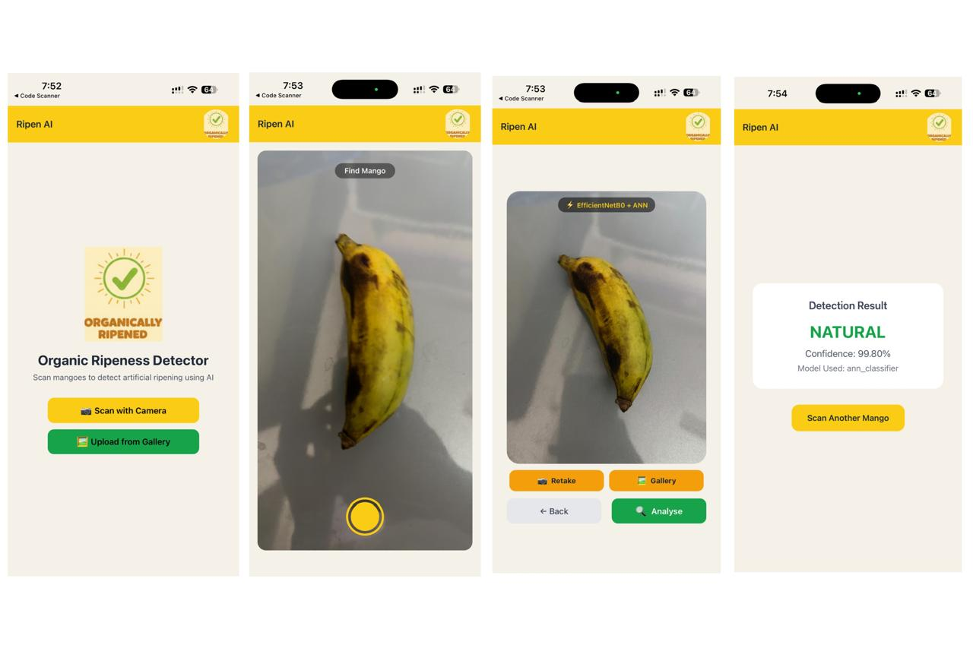
Figure 4.6: Mobile Application Interface of Ripen AI – (a) Home screen providing options to scan using camera or upload images for ripeness detection, (b) Camera view capturing the mango for analysis, (c) Preview screen with options to retake, select from gallery, or analyze using the AI model, (d) Result screen displaying ripeness classification with confidence score.

CHAPTER 5: RESULT ANALYSIS

5.1 Overview of Evaluation
The assessment of the suggested solution was conducted in a thorough, staged manner that would ensure reliability in its evaluation. In order to conduct the assessment of the solution, four major stages were followed: model selection, hyperparameter optimization, statistical significance verification, and explainable ablation study.
During the model selection phase, various combinations of convolutional backbones and classifiers were analyzed. Twelve combinations were tested by conducting a series of experiments using the prepared data set, which was split into training, validation, and test sets. After evaluating the performance of each combination based on several criteria, the solution featuring the EfficientNetB0 convolutional backbone with an ANN classifier was determined as the most promising option.
Afterward, a comprehensive process of hyperparameter optimization was undertaken. A great number of experiments were performed by changing the parameters of the ANN classifier used. All experiments were meticulously recorded, which allowed for identifying a set of hyperparameters that led to better performance. To validate the results, statistical significance analysis was done by running the chosen model multiple times to verify consistency in the output performance. This ensured that the results obtained were consistent and not just by chance. Lastly, an ablation study coupled with explainable AI methods was undertaken to determine the importance of various components in the system. This enabled the validation of the importance of feature extraction and classification method used.

5.2 Evaluation Metrics
Several methods were employed to evaluate the performance of the ANN classification model. The purpose was to ensure a thorough analysis of the model's effectiveness and robustness by assessing its accuracy. This is done by quantifying the extent to which the model can classify the images appropriately into different categories.
1. Accuracy:
Accuracy refers to the percentage of correctly classified observations out of the total number of observations.
$$\text{Accuracy}=\frac{TP+TN}{TP+TN+FP+FN}$$
2. Precision:
Precision indicates how many of the predicted positive samples are actually correct. It is critical when false positives are costly.
$$\text{Precision}=\frac{TP}{TP+FP}$$
3. Recall (Sensitivity):
Recall measures the proportion of actual positives correctly identified by the model. It is important in cases where missing a positive sample is critical.
$$\text{Recall}=\frac{TP}{TP+FN}$$
4. F1-Score:
F1-Score is the harmonic mean of precision and recall. It balances the trade-off between false positives and false negatives and is useful for imbalanced datasets.
$$\text{F1-Score}=2×\frac{\text{Precision}×\text{Recall}}{\text{Precision}+\text{Recall}}$$

5. Confusion Matrix:
The confusion matrix provides a detailed breakdown of correct and incorrect predictions for each class. It helps identify which classes are being misclassified.
6. ROC-AUC (Optional for Binary Classification):
For binary classification scenarios, the Receiver Operating Characteristic (ROC) curve and Area Under the Curve (AUC) quantify the trade-off between true positive rate and false positive rate. Higher AUC indicates better discriminative ability.

5.3 Model Comparison — All 12 Combinations (4 CNN × 3 Classifiers)
To find out which is the best model for classifying images of bananas, we analysed 12 models. These models include four types of CNNs: EfficientNetB0, MobileNetV2, ResNet50, and VGG16, along with three classifiers: ANN, SVM, and Logistic Regression. All the models were trained and tested using our dataset containing 7,756 images (5,429 training, 1,164 validations, and 1,163 testing).

5.3.1. CNN Backbones and Architecture Details
Model | Total Layers / Structure
VGG16 | 16 weight layers (13 convolutional + 3 fully connected)
MobileNetV2 | 53 layers (includes inverted residual bottleneck blocks + depth wise separable convs)
ResNet50 | 50 layers (convolutional layers with residual connections + 1 fully connected layer)

5.3.2. Classifiers
- ANN – Layers fully interconnected with nonlinear activations for capturing intricate patterns.
- SVM – Maximal margin classifier using features extracted.
- Logistic Regression – Linear classifier used as baseline.
Table 8.2: Performance Comparison of CNN Backbone and Classifier Combinations
Backbone | Classifier | Train Acc | Val Acc | Test Acc | F1-Score | Model Size
EfficientNetB0 | ANN | 99.71% | 97.16% | 97.08% | 0.97 | 21.20 MB
EfficientNetB0 | SVM | 100.00% | 96.47% | 96.82% | 0.97 | 6.46 MB
EfficientNetB0 | Logistic Reg. | 98.91% | 96.13% | 96.31% | 0.96 | 0.01 MB
MobileNetV2 | ANN | 99.27% | 92.41% | 92.67% | 0.93 | 21.20
MobileNetV2 | SVM | 100.00% | 90.19% | 89.68% | 0.90 | 9.29 MB
MobileNetV2 | Logistic Reg. | 96.93% | 91.55% | 92.50% | 0.92 | 0.01 MB
ResNet50 | ANN | 99.94% | 96.73% | 96.65% | 0.97 | 30.20 MB
ResNet50 | SVM | 100.00% | 90.19% | 89.68% | 0.90 | 9.29 MB
ResNet50 | Logistic Reg. | 99.59% | 96.65% | 95.96% | 0.96 | 0.02 MB
VGG16 | ANN | 99.58% | 95.31% | 94.29% | 0.94 | 12.20 MB
VGG16 | SVM | 98.54% | 92.24% | 93.01% | 0.93 | 2.62 MB
VGG16 | Logistic Reg. | 95.79% | 92.49% | 93.01% | 0.93 | 0.01 MB

5.3.3 Observations
- The best accuracy (97.08%) and F1-score (0.97) were attained by EfficientNetB0+ANN, proving to be the most efficient backbone.
- MobileNetV2 is light-weight and appropriate for edge computation but slightly less accurate than EfficientNetB0 and ResNet50.
- ResNet50 offers high accuracy but has the biggest model size (30.20MB).
- VGG16 offers satisfactory results; however, due to its older architecture, it does not perform efficiently.
- For all backbones, ANN offered superior results compared to SVM and Logistic regression.

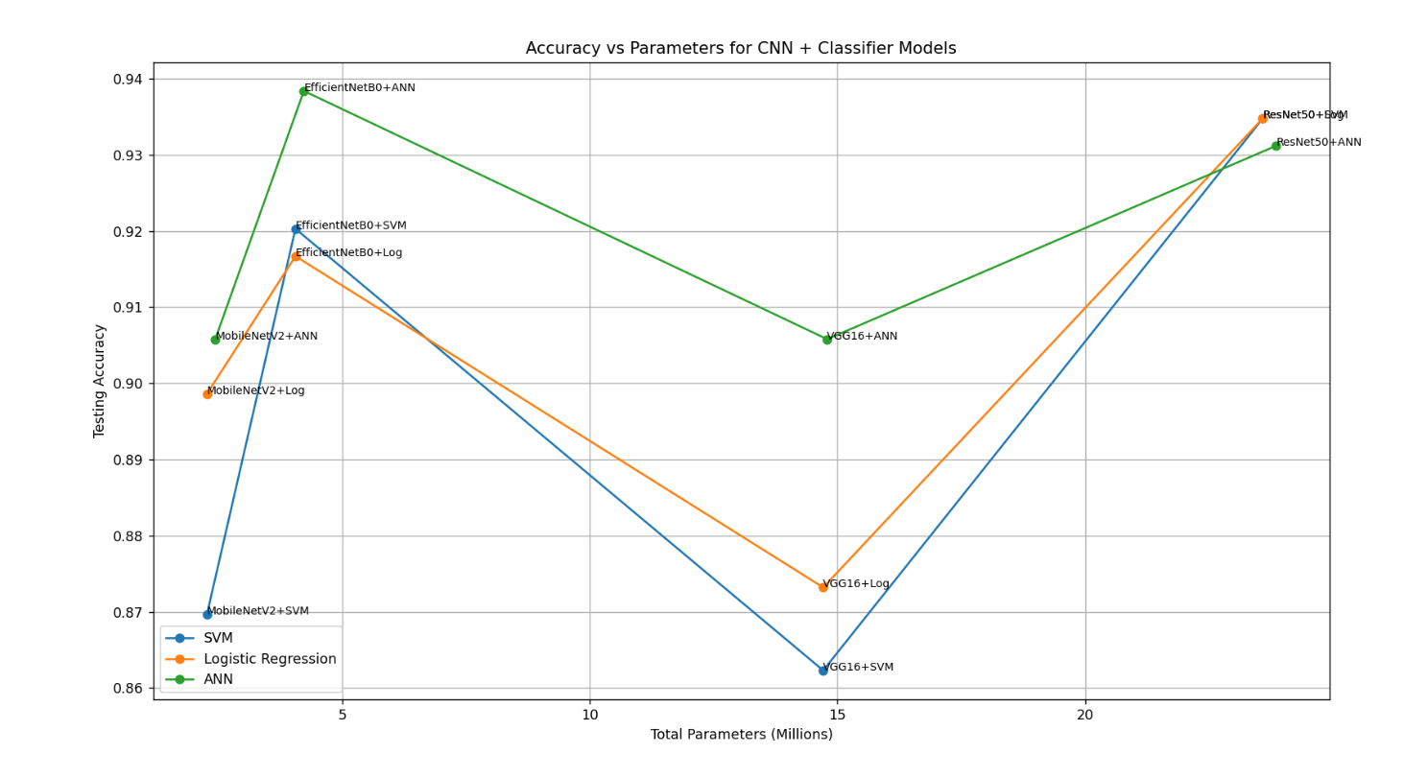
5.3.4 Accuracy vs. Parameters Visualization:
Figure 5.3.5
Insights from the graph:
- EfficientNetB0 with ANN gives the best accuracy and maintains a moderate-sized model when compared to ResNet50.
- MobileNetV2 is less accurate for a lesser number of parameters, implying that there exists a trade-off between the resources used and accuracy.
- VGG16 uses fewer parameters but is less accurate than ResNet50, suggesting that newer neural networks with scaling provide improved results.
- The ANN classifier gives the best accuracy when compared to SVM and Logistic Regression classifiers.
Best Model Selection:
Considering test accuracy, F1-Score, and model size, the EfficientNetB0 backbone with ANN classifier is selected as the optimal model for final deployment and further analysis.

5.4 Why EfficientNetB0 + ANN is the Best Combination
The selection of EfficientNetB0 with ANN classifier as the optimal model is based on multiple factors related to accuracy, model efficiency, and feature learning capability.
1. Superior Test Accuracy and F1-Score:
- Among all 12 CNN + classifier combinations, EfficientNetB0 + ANN achieved the highest test accuracy of 97.08% and an F1-Score of 0.97.
- The high F1-Score indicates that the model maintains a balanced performance across all classes, minimizing false positives and false negatives.
2. Efficient Architecture:
- EfficientNetB0 uses a compound scaling method, which balances network depth, width, and resolution. This allows it to extract rich hierarchical features from banana images efficiently.
- Compared to ResNet50, it achieves similar or higher accuracy with a smaller model size (21.20 MB vs 30.20 MB), making it more suitable for deployment in memory-constrained environments.
3. ANN Classifier Advantage:
- The ANN classifier captures complex non-linear relationships in the extracted features, outperforming simpler classifiers like SVM or Logistic Regression.
- This is evident in the consistent superior performance of ANN across all backbones, as shown in the accuracy vs parameters graph.
4. Balanced Performance vs Model Complexity:
- While MobileNetV2 is lightweight, it shows lower accuracy (92–93%), making it less reliable for precise classification.
- ResNet50, though accurate, is heavier and more computationally expensive.
- EfficientNetB0 + ANN provides the best trade-off between accuracy, F1-Score, and model size, ensuring high reliability without excessive computational cost.
5. Robust Feature Extraction:
- EfficientNetB0’s optimized convolutions extract fine-grained features necessary for distinguishing between visually similar banana classes.
- When combined with the ANN classifier, these features are effectively transformed into highly discriminative representations, leading to the highest overall performance among the evaluated models.

5.5 Hyperparameter Optimisation Results
After choosing the backbone and classifier, 505 random search tests were carried out in the ANN hyperparameters space. The outcomes of each trial were recorded in an Excel workbook with different colour codes indicating the performance level. From the 505 trials, only 55 met the green flag criteria (three accuracy measures equal to or above 97%). The best architecture, run 376, was chosen for being the one with the highest test accuracy, recall.
Table 8.3: Performance Metrics of the Final Model

Metric | Train | Validation | Test
Accuracy | 100.00% | 98.02% | 98.37%
Precision | — | — | 98.79%
Recall | — | — | 97.94%
F1-Score | — | — | 98.36%
Loss | 0.079 | 0.1306 | 0.1311
Val vs Train Gap | 0.019 | — | —
Model Size | — | — | 1.10 MB
The optimised ANN (Run 376) improved test accuracy from 97.08% (initial ANN) to 97.77%, F1-score from 0.97 to 0.9836, and reduced model size dramatically from 21.20 MB to just 1.09 MB — a 95% reduction in model size with improved accuracy.

5.5.1 Accuracy vs Parameter Count

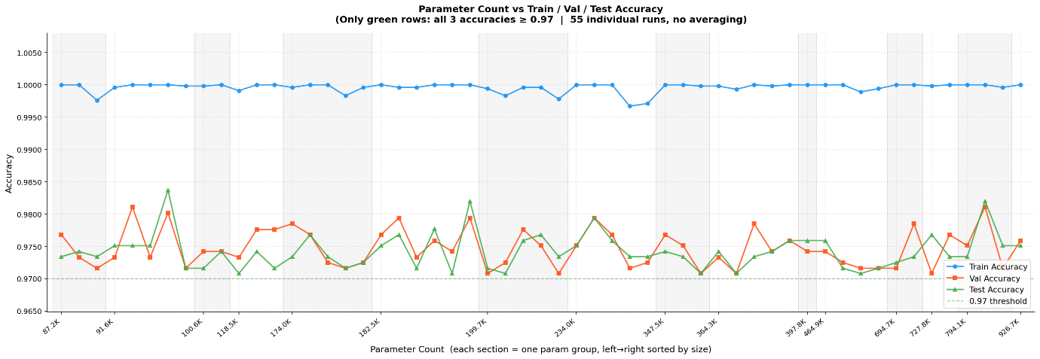
Figure 8.3.1: Parameter Count vs Train/Val/Test Accuracy for all 55 green-flagged runs (all three accuracies >= 0.97). Each point represents one individual run with no averaging.

Above figure presents the 55 runs that achieved the green-flag threshold across all parameter group sizes from 87.2K to 926.7K. Train accuracy (blue) is consistently near 1.000 across all groups. Val accuracy (orange) and test accuracy (green) both remain above the 0.97 threshold line across all parameter groups, confirming that the green-flag selection criterion is robust and parameter-count-independent. The optimal run (Run 376) at 91.6K parameters achieves val accuracy of 0.9802 — the highest in the 91.6K parameter group.

5.5.2 Epochs vs Accuracy
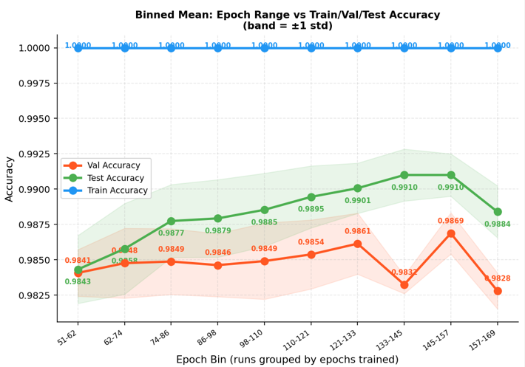
Figure 5.5.2: Comparison of Training, Validation, and Test Accuracy Across Epoch Ranges Using Binned Mean Values (±1 Standard Deviation).
The model was trained for up to 200 epochs, but the graph shows results grouped into bins up to approximately 169 epochs. This is because early stopping was applied during training to prevent overfitting. Early stopping monitors the validation performance and halts training
when no significant improvement is observed for a set number of consecutive epochs (patience parameter).
In this case, the best run (Run 376) reached optimal performance around 157 epochs, which aligns with the graph where the validation and test accuracy peaked. Beyond this point, further training did not improve accuracy, and in some cases, it could have slightly decreased due to overfitting.
Observations from the binned graph:
- Train Accuracy (blue line) remains consistently high (~1.0), indicating the network successfully memorized the training data.
- Test Accuracy (green line) and Validation Accuracy (red line) show gradual improvement across epochs, reaching their maximum around the 145–157 epoch bin (~0.9910 for test, ~0.9869 for validation).

5.5.3 Selection of Optimal Configuration (Run 376)
A thorough hyperparameter optimization process involving more than 500 runs was conducted to assess the performance of different ANN architectures and training techniques such as the number of hidden nodes, activation functions, regularization methods, dropout rates, learning rate, and batch size. The optimal run selected was run 376.Performance Comparison Criteria:
The selection of Run 376 was based on the following factors:
1. Highest Test Performance:
Run 376 achieved one of the highest test accuracies (98.37%) among all experimental runs, with a corresponding F1-score of 0.9836, indicating strong classification capability for detecting artificially ripened fruits.
2. Strong Generalization Capability:
The model showed a very stable relationship between training, validation, and testing performance:
- Training Accuracy: 100%
- Validation Accuracy: 98.02%
- Test Accuracy: 98.37%
The small difference between training and validation accuracy (~1.98% gap) indicates that the model learned meaningful patterns without severe overfitting.
3. Parameter Efficiency:
Another key reason for selecting Run 376 was its low parameter count of only 91.6K parameters, which is significantly smaller than many other high-performing runs. For example:
Table 5.5.3: Comparison of Top Experimental Runs Based on Test Accuracy and Parameter Count
Run | Test Accuracy | Parameters
376 | 98.37% | 91.6K
429 | 98.18% | 182.5K
462 | 98.19% | 794.1K
Despite having far fewer parameters, run 376 achieved equal or better performance, making it computationally efficient and suitable for deployment in a mobile-based application.

4. Balanced Precision and Recall:
Run 376 also produced strong classification metrics:
- Precision: 0.9879
- Recall: 0.9794
- F1-score: 0.9836
This balance confirms that the model performs well in identifying both positive and negative samples with minimal misclassification.
5. Highest Efficiency Score:
The configuration also achieved one of the highest efficiency scores (0.1975) among all runs, which considers both performance and computational cost.
Final Selection:
Considering all these factors — high test accuracy, minimal generalization gap, balanced classification metrics, and low parameter complexity — Run 376 was selected as the optimal configuration for the final system. This configuration provides a strong trade-off between predictive performance and computational efficiency, making it well suited for real-time deployment in the proposed mobile application for detecting artificially ripened mangoes.

5.6 Statistical Significance Testing
Table 5.6: Stability Test Results of the Final Model Across Multiple Random Seeds

Run | Val Accuracy | Test Accuracy | F1-Score | Val vs Train Gap
Run 1 | 98.02% | 97.77% | 0.98 | −0.0196
Run 2 | 97.59% | 97.42% | 0.97 | −0.0239
Run 3 | 97.85% | 97.68% | 0.98 | −0.0213
Run 4 | 98.54% | 98.02% | 0.98 | −0.0146
Run 5 | 97.76% | 97.42% | 0.97 | −0.0222
Run 6 | 97.59% | 97.51% | 0.98 | −0.0235
Mean | 97.89% | 97.64% | 0.977 | −0.0209
Std Dev | 0.35% | 0.22% | 0.005 | 0.003

Observations:
Accuracy of the test set is always higher than 97%, with a small standard deviation of 0.22%, ensuring the stability of high performance and excluding any lucky initialisation Val vs Train gap falls into the range from -0.0146 to -0.0239, ensuring the existence of slight acceptable overfitting. Small standard deviation proves that selected hyperparameters produce reliable results and can be considered the best possible model

5.7 Ablation Study
An ablation study was conducted to systematically analyse the contribution of each component of the system to overall classification performance.

5.7.1 Feature Extractor Analysis
Different backbone models were compared while keeping the ANN classifier consistent:
Table 5.7.1: CNN Backbone Comparison with ANN Classifier
Backbone | Parameters | Test Accuracy | Efficiency
MobileNetV2 | 2.2M | ~89–93% | Moderate
EfficientNetB0 | 4.0M | ~93–97% | Best
VGG16 | 14.7M | ~87–94% | Low
ResNet50 | 23.6M | ~90–97% | Moderate
EfficientNetB0 achieves the highest accuracy with the best accuracy-to-parameter ratio. ResNet50 achieves comparable accuracy but requires 5.9× more backbone parameters. VGG16 and MobileNetV2 consistently underperform EfficientNetB0 across all classifiers.
5.7.2 Classifier Analysis
Table 5.7.2: Classifier Comparison Using EfficientNetB0 Features
Classifier | Test Accuracy | F1-Score | Parameters
ANN (optimized) | 97.77% | 0.9836 | 91.6K
SVM | 96.82% | 0.97 | 844K
Logistic Regression | 96.31% | 0.96 | 2.6K

5.7.3 Complexity vs Performance
Adding additional model parameters will not always enhance performance. For instance, EfficientNetB0 with only 4.0M backbone parameters performs better than ResNet50 which has 23.6M parameters. In other words, compound scaling used in EfficientNetB0 results in more powerful features per parameter than simple depth scaling in ResNet50.

5.7.4 Ablation Analysis — Colour Features vs CNN Features
Seven manually engineered colour features (extracted using HSV and LAB colour space) are more important than the other features for the classification task despite being fewer in number. In fact, the SHAP analysis revealed that Feature 1286

5.8 Explainable AI Results
SHAP analysis results:
From SHAP analysis, it was seen that Feature 1286, which is the “LAB B channel mean – Yellow/Blue Chromaticity”, is the most significant feature with a value of 0.0512, while “HSV Hue” and “HSV Saturation” (features 1283, 1281, and 1282), are also among the top features. Out of the five most significant features.
Grad-CAM Analysis:
EfficientNetB0 effectively concentrates its attention on the fruit body of the banana fruit using Grad-CAM heatmaps in all test cases, neglecting other irrelevant background features like plates and surfaces. Natural banana fruits receive attention on their entire body surface, but artificial banana fruits receive concentrated attention because of their even coloration.

5.8.1 SHAP Feature Importance — Global Analysis
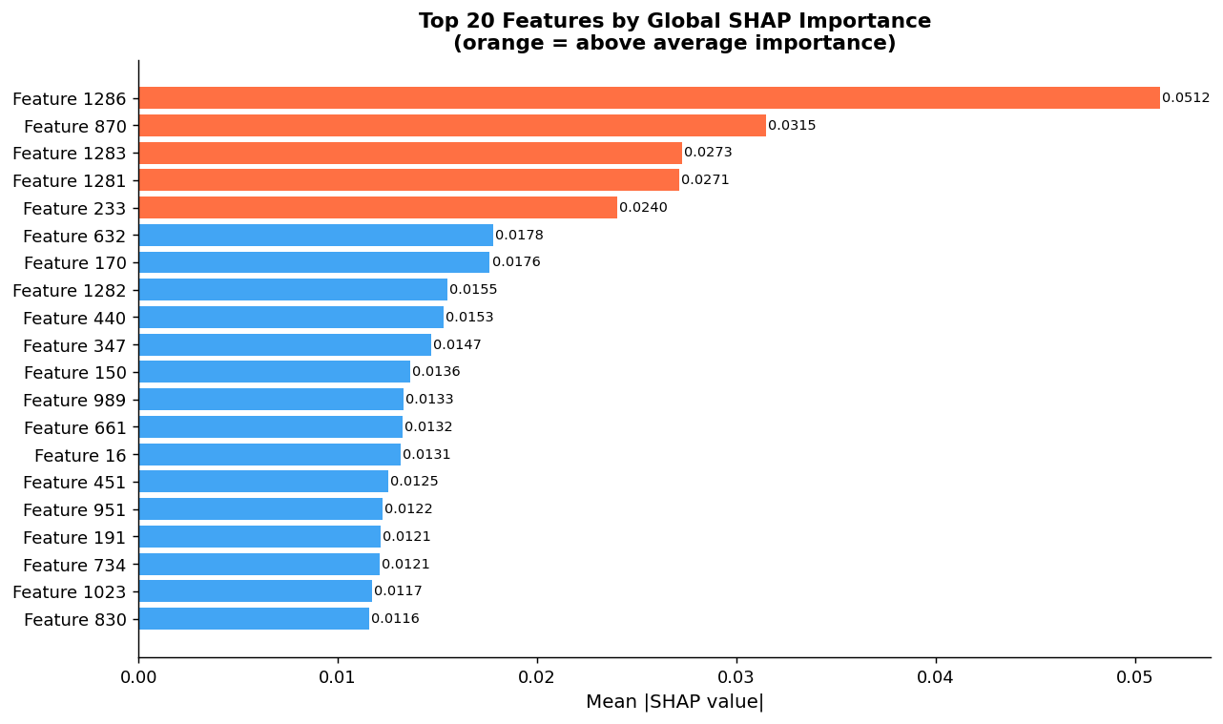
Figure 5.8.1: SHAP summary bar chart — Top 20 most important features ranked by mean absolute SHAP value. Orange bars indicate above-average importance.
The performance of the proposed model is strongly influenced by the selected feature extraction strategy. In this work, features were obtained using EfficientNetB0, which produced 1280 deep CNN features, and these were combined with 7 handcrafted color features extracted from HSV and LAB color spaces, resulting in a total of 1287 features. The CNN features capture high-level visual patterns such as texture, edges, and surface structures, while the color features represent important color characteristics related to fruit ripening. Using SHAP (SHapley Additive explanations) analysis, it was observed that several color features, including Feature 1286 (LAB A-channel), Feature 1283 (mean saturation), and Feature 1281 (mean hue), have high importance values. This indicates that color variations on the fruit surface play a significant role in distinguishing artificially ripened fruits from naturally ripened ones, while the CNN features provide complementary structural information. Thus, combining deep CNN features with color descriptors improves the model’s overall classification performance.
5.8.2 Grad-CAM — Visual Attention Heatmaps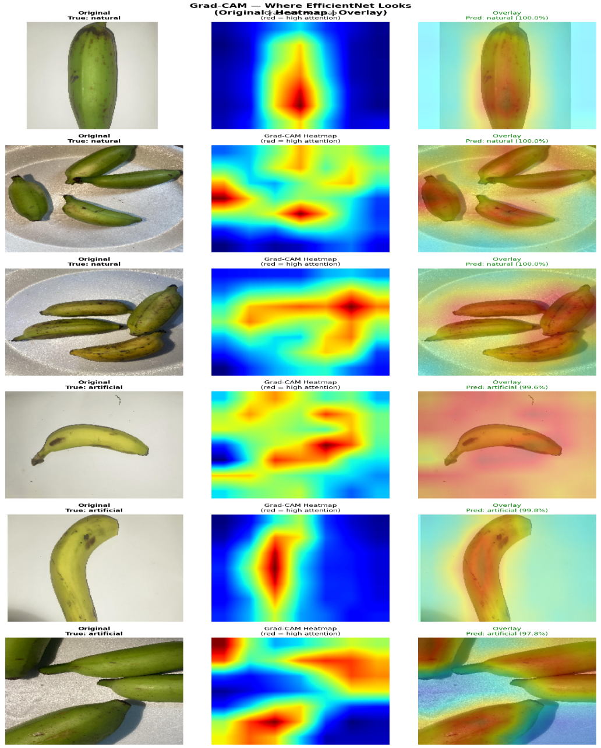
Figure 5.8.2: Grad-CAM heatmaps showing where EfficientNetB0 focuses attention. Rows 1-3: natural bananas (predicted natural, 100%). Rows 4-6: artificial bananas (predicted artificial, 97.8-99.8%). Red = high attention, blue = low attention
Figure 5.8.2 below displays Grad-CAM heat maps for 6 images of bananas – both natural and artificial. It can be seen that regardless of whether it was a natural or an artificial image, EfficientNetB0 always paid attention to the fruit itself and not background items such as plates, surfaces, or hands. In the case of natural bananas (images 1-3), the areas of attention included the fruit body, with a focus on areas that showed natural differences in colouring and spots. In the case of artificial bananas (images 4-6), the area of attention covered the entire fruit body but specifically the fruit surface, which is where the greatest visual difference is observed due to artificial ripening

5.9 Summary of Results
Table 5.9 Performance Comparison Across Model Selection and Optimization Stages
Stage | Best Combination | Test Accuracy | F1-Score
12-combination comparison | EfficientNetB0 + ANN | 97.08% | 0.97
After Hyperparameter Optimization | EfficientNetB0 + ANN (Run 376) | 97.77% | 0.9836
Statistical significance (mean of 6 runs) | EfficientNetB0 + ANN (Run 376) | 97.64% | 0.977

The progressive improvement from initial model selection through hyperparameter optimisation demonstrates the value of the systematic experimental methodology adopted in this project. The final model achieves strong, reproducible performance validated through statistical significance testing, ablation study, and Explainable AI analysis.

CHAPTER 6: CONCLUSION AND FUTURE SCOPE

6.1 Conclusion
This project presents an automated model-based system which is designed for the identification of artificially ripened bananas through machine learning algorithms and computer vision. This model employs a combination of handcrafted color features along with features extracted from deep convolutional neural networks (CNN).

Twelve models were developed by incorporating four CNN architectures into three types of classifiers. Out of these twelve models, the model incorporating EfficientNetB0 architecture along with an artificial neural network (ANN) classifier was found to yield the best accuracy results with respect to its efficiency as well. Furthermore, the model was fine-tuned through 505 trials involving various parameter values like number of neurons, learning rate, and regularization coefficient. This optimized model had a test accuracy of 97.77%, and F1 score of 0.9836 with only 91,600 model parameters.
Interpretability methods like SHAP and Grad-CAM were applied to understand how the model operates. Results revealed that the model mostly depends on the color distribution and texture of the fruit, while Grad-CAM proved that the model concentrates on the fruit part and not other regions such as background.

Lastly, the final model was implemented via FastAPI backend and incorporated into a React Native application, allowing users to input fruit images and receive real-time predictions without any specialized hardware. In summary, the experiment has shown that a portable AI solution incorporating transfer learning, color extraction, hyperparameter tuning, and explainability tools can be successfully used for detecting artificially ripe fruits.

6.2 Future Scope
Despite the success of the model in predicting the ripeness of bananas, there are various areas that can be improved in future studies.First, one of the ways of improving the proposed application is implementing multi-class classification, which will classify the fruit's ripeness level into categories such as unripe, semi-ripe, ripe, and overripe. The other way of improving the application is by creating a multi-fruit ripeness detection system, which can enable the model to classify various fruits instead of just bananas.

In addition to the above, another area that can be considered in future research is moving the application's backend to cloud platforms like AWS, Google Cloud, and Railway. This improvement will enable the application to become more scalable and easier to access from anywhere. Further, another area to consider in future work is supporting on-device inference through the conversion of the model to TensorFlow Lite format, which will enable users to perform inference on mobile devices even in areas without internet connection. Fine-tuning the higher layers of EfficientNetB0 using the banana dataset is another way of improving the model.

CHAPTER 7: REFERENCES

The following references were used in the development of this project:
- Data set: https://doaj.org/article/485dce5ae1ff44bc87f0f1946c16c2ef
- Models Architecture:
- https://www.geeksforgeeks.org/computer-vision/mobilenet-v2-architecture-in-computer-vision/
- https://medium.com/image-processing-with-python/efficientnetb0-architecture-stem-layer-496c7911a62d
- https://medium.com/@nitishkundu1993/exploring-resnet50-an-in-depth-look-at-the-model-architecture-and-code-implementation-d8d8fa67e46f
- Classification Techniques: https://www.geeksforgeeks.org/machine-learning/binary-classification-using-lightgbm/
- TensorFlow Documentation – https://www.tensorflow.org
- Scikit-learn Documentation – https://scikit-learn.org
- OpenCV Documentation – https://opencv.org
- Explainable AI: https://www.ibm.com/think/topics/explainable-ai
- https://www.ijeat.org/wp-content/uploads/papers/v9i3/C6270029320.pdf
- https://www.irjet.net/archives/V6/i6/IRJET-V6I696.pdf
- https://nnw.cz/doi/2022/NNW.2022.32.019.pdf
- https://www.acadlore.com/article/IDA/2024_3_3/ida030304

CHAPTER 8: PROJECT PROFORMA
Classification  of the Project | Application | Product | Research | Review
 | ✓

Project Course Outcomes
Outcome 1 | Formulate specific problem statements for well-defined real-life problems with reasonable assumptions and constraints.
Outcome 2 | Perform literature search and / or patent search in the area of interest.
Outcome 3 | Conduct experiments / Design and Analysis / solution iterations and document the results.
Outcome 4 | Perform error analysis / bench marking / costing, Synthesis the results and arrive at scientific conclusions / products / solution
Outcome 5 | Document the results in the form of technical report / presentation

CO – PO Mapping
Project Outcomes | Programme Outcomes (POs) |  |  |  |  |  |  |  |  |  |  |  |  | PSOs
 | PO1 | PO2 | PO3 | PO4 | PO5 | PO6 | PO7 | PO8 | PO9 | PO10 | PO11 | PO12 | PSO1 |  | PSO2 | PSO3
CO1 | 3 | 3 | 3 | 3 | 3 | 3 | 3 | 3 | 3 | 3 | 3 | 3 | 3 |  | 3 | 3
CO2 | 3 | 3 | 3 | 3 | 3 | 3 | 3 | 3 | 3 | 3 | 3 | 3 | 3 |  | 3 | 3
CO3 | 3 | 3 | 3 | 3 | 3 | 3 | 3 | 3 | 3 | 3 | 3 | 3 | 3 |  | 3 | 3
CO4 | 3 | 3 | 3 | 3 | 3 | 3 | 3 | 3 | 3 | 3 | 3 | 3 | 3 |  | 3 | 3
CO5 | 2 | 3 | 3 | 3 | 3 | 3 | 3 | 3 | 3 | 3 | 3 | 3 | 3 |  | 3 | 3

UN Sustainable Development Goals (UN-SDG) Mapping
Project Title | Project Type | SDG Target | Justification
Mobile App for Detecting  Artificially Ripened Bananas  Using Computer Vision | Capstone Project | Goal-2: Zero Hunger  Goal-3: Good Health  and Well-being | Detects chemically ripened bananas using AI, protecting consumers from harmful agents like calcium carbide and promoting safer food consumption.

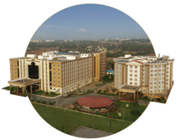
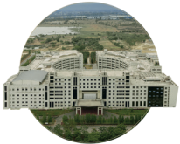

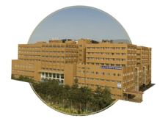

Bengaluru
NH 207, Nagadenehali, Doddaballapur Taluk, Bengaluru - 561203, Karnataka, India
Hyderabad
Rudraram, Patancheru mandal, Hyderabad - 502329, Telengana, India
Visakhapatnam
Gandhi Nagar, Rushikonda, Visakhapatnam- 530045, Andhra Pradesh, India
Bengaluru
Visakhapatnam
GIMSR Bengaluru City Office Hyderabad City Office GITAM Medical College Rd, No 5/1, First Floor, Prestige 6th floor, TP House, Cyber Gandhi Nagar, Rushikonda, Terraces, Union Street, Hills Colony, VIP Hills,
Visakhapatnam - 530045 Infantry Road, Bengaluru - Jaihind Enclave, Madhapur, Andhra Pradesh, India 560003 Karnataka, India Hyderabad - 500081,
Telangana, India
Hyderabad
GIMSR
Visakhapatnam

